Self-Pruning Neural Networks: Assignment Report

1. The Mechanics of the L1 Penalty on Sigmoid Gates
To achieve dynamic self-pruning during training, we apply an L1 regularization penalty directly to the outputs of the learnable sigmoid gates.
In standard weight decay (L2 regularization), weights are pushed towards zero, but the gradient scales with the magnitude of the weight, meaning it rarely reaches exactly zero. The L1 norm, however, applies a constant gradient penalty regardless of the value's magnitude. Because our architectural gates are passed through a sigmoid function (bounding them strictly between 0 and 1), their L1 norm is simply the sum of all gate values.
By adding this sum to our loss function, the network is constantly penalized for every active (non-zero) gate. During backpropagation, this constant penalty forces the underlying gate_scores into large negative numbers. Once a score is sufficiently negative, its sigmoid output maps exactly to $0.0$. At this point, the multiplied weight has no effect on the forward pass, effectively and dynamically pruning the connection from the network.

2. Results Summary: The Sparsity-vs-Accuracy Trade-off
The network was trained over 10 epochs on the CIFAR-10 dataset across five different penalty strengths (Lambda (λ)). As Lambda (λ) increased, the network pruned a proportionally higher percentage of its connections.
Notably, we observed a distinct "regularization sweet spot." Accuracy actually improved as sparsity increased from 13% up to roughly 60%, demonstrating that moderate pruning acts as a powerful regularizer against overfitting. Pushing the sparsity higher to 83% caused a slight degradation, and the network finally collapsed when forced to 97.8% sparsity.
Lambda (λ) | Test Accuracy (%) | Sparsity Level (%)
1 | 55.10% | 13.13%
2 | 56.42% | 34.10%
5 (Best) | 56.56% | 59.79%
15 | 55.96% | 83.53%
100 | 52.02% | 97.84%
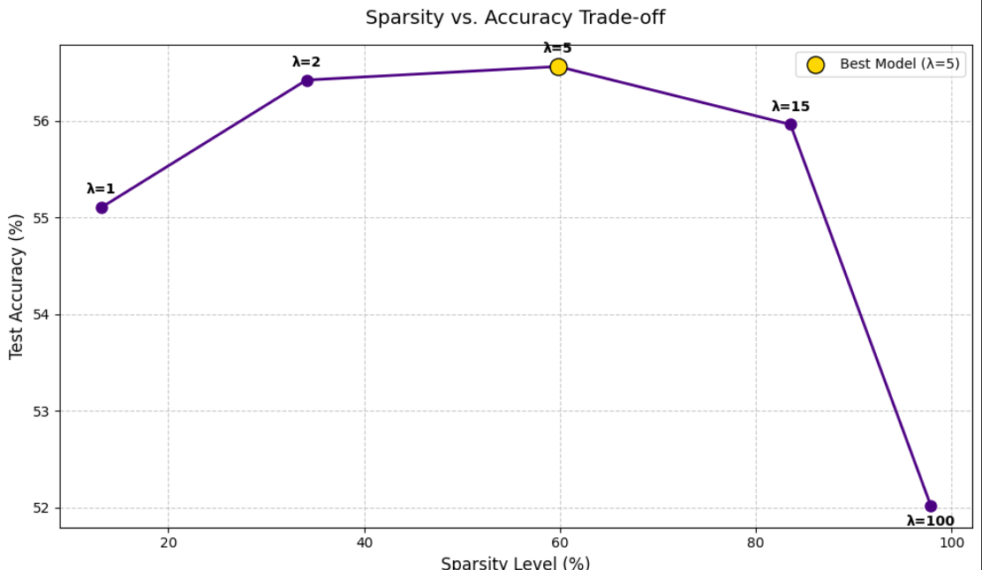
3. Final Gate Value Distribution
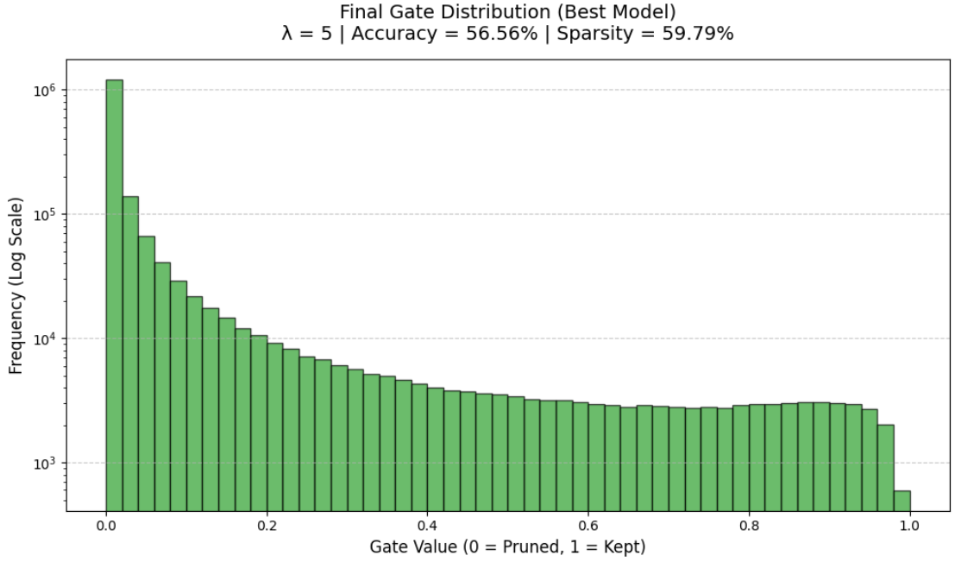
Analysis of the Distribution
The logarithmic histogram above illustrates a highly bimodal distribution of the final gate values, which is the exact hallmark of a successful self-pruning mechanism:
- The Pruned Spike (0.0): The massive concentration of values exactly at zero (exceeding 1,000,000 on the logarithmic scale) represents the 59.79% of network connections that were successfully neutralized. The L1 penalty dominated the loss landscape for these specific weights, driving their underlying gate scores down until the sigmoid output collapsed entirely to zero.
- The Active Plateau (0.4 to 1.0): The distinct, steady distribution of values clustered away from zero represents the "surviving" connections. For these weights, the gradient from the Cross-Entropy classification loss overpowered the L1 penalty, forcing the gates to remain open. The network independently decided that these specific feature detectors were absolutely critical for recognizing the CIFAR-10 images.
4. Conclusion
This experiment successfully demonstrates the viability of training a neural network to dynamically discover its own optimal, sparse architecture on the fly. By augmenting a standard linear layer with a learnable gating mechanism and applying a targeted L1 sparsity penalty, the network was forced to independently evaluate the utility of every single connection during backpropagation.
Crucially, the results highlight that pruning is not merely a post-training compression technique, but a powerful regularizer when applied dynamically during training. At a moderate penalty threshold (Lambda (λ) = 5), forcing the network to abandon nearly 60% of its parameters actively prevented overfitting and improved the overall test accuracy to a peak of 56.56%. This aligns strongly with modern deep learning theories, such as the Lottery Ticket Hypothesis, proving that within a dense, over-parameterized network lies a leaner, more robust sub-network capable of superior generalization.

